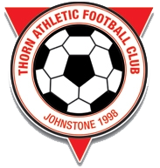

THORN ATHLETIC COMMUNITY FOOTBALL CLUB

Mission Statement
Vision
To be the football club of choice in Johnstone and the wider community.
Mission
- Development of youth and adult football and footballers. To this end we will provide within the Johnstone and wider Renfrewshire area a football programme that prepares young footballers both physically and mentally for adult football.
- Our principal philosophy is the provision of a safe and supportive community based environment, which encourages skill development, fitness, fair play and teamwork through and ethos of positive coaching.
Values
- The physical and emotional safety of our players is paramount.
- Whilst success on the field is important so are the concepts of fair play, team-work and team spirit.
- The administration of the Thorn Athletic Community Football Club will be professional, transparent and fair; all duties will be carried out honestly and with integrity.
- We will care for the environment in which we play both home and away.
- We will be part of the community in which we play and to this end co-operate and support other sporting clubs where possible.
- Thorn Athletic Community Football Club believes in fair and equal treatment for all persons involved.

